Personal Information
Full name: | Nakul Kumar Bali
Identity no.: | 8502136159180
Date of birth: | 1985-02-13
Nationality: | Indian Citizen
Residence Status:  Marital status: | Permanent Residence  Single
Dependants: | 0
Languages: | English
Address: | 22 Taylor Avenue, Randpark  Ridge, Johannesburg, 2169
Telephone: | +27 (0) 79 284 0460 (cell)
E-mail:  LinkendIn: | nakul.bali@hotmail.com  Nakul Bali

Skill Summary

Software Development
Skill | Years | Last used
Eclipse | 7 | Current
IntelliJ Idea | 4 | Current
Java | 7 | Current
Spring boot | 3 | Current
Kubernetes | 1 | Current
Docker | 1 | Current
Azure Pipelines | 1 | Current
.Net Core | 3 | Current
GO | 1 | Current
Android SDK | 4 | Current
MVC Design Patterns | 5 | Current
RESTful Web Services | 5 | Current
SOAP Web Services | 5 | Current
XML | 6 | Current
HTML | 4 | Current
CSS | 3 | Current
JSON | 5 | Current
Visual Studio (C#) | 4 | Current
C | 6 | Current
C++ | 6 | Current
Sharepoint | 2 | Current
iOS SDK(Cocoa Touch Framework) | 3 | Current
Objective-C | 2 | Current
XCode | 3 | Current
Entity Framework | 3 | Current
IBM Bluemix | 1 | Current
Cognitive Computing | 1 | Current
Artificial Intelligence | 2 | Current
Windows Mobile | 2 | Current
Windows Universal | 2 | Current
Blackberry SDK(OS 7 and below) | 2 | 2013
Blackberry SDK(OS 10) | 1 | 2013
Blackberry JDE | 2 | 2013
Blackberry Momentics IDE | 1 | 2013
Spring Framework | 1 | 2008
Hibernate ORM | 1 | 2008
Genetic Algorithms | 1 | 2008
Neural Networks | 1 | 2008
JSP | 3 | 2008
EJB | 3 | 2008
Servlets | 3 | 2008
Netbeans | 3 | 2008
Shell Scripting | 3 | 2012
Ant Algorithms | 1 | 2008

Databases
Skill | Years | Last used
SQLite | 3 | 2017
SQL | 5 | 2018
MySQL | 5 | 2018
PostgresSQL | 2 | 2009
Orcale 10 | 3 | 2012
Orient DB (No SQL) | 1 | Current

Operating Systems
Skill | Years | Last used
iOS | 3 | Current
MAC OSX | 3 | Current
Windows Server 2008 | 4 | Current
Windows Server 2012 | 3 | Current
Windows 7 | 3 | Current
Windows 8 | 2 | Current
Windows 10 | 1 | Current
Android | 4 | Current
Red Hat | 5 | 2012
Fedora | 6 | 2012
Cent OS | 5 | Current
Solaris | 3 | 2012

Source and Version Control
Skill | Years | Last used
GIT | 3 | Current
Microsot Team Foundation Server | 4 | Current
GIT-TF (GIT for TFS) | 2 | Current
SVN | 1 | 2013

Other Skills
Skill | Years | Last used
Applied for Patent for new Encryption Algorithm | 1 | 2007
AGILE and SCRUM Development | 4 | Current
Network Traffic Tools (Wireshark) | 7 | Current
VoiceMail Platform | 3 | 2012
IIS Server | 4 | Current
Tomcat | 5 | 2012
Jboss | 4 | 2010
WebLogic | 1 | 2009
Apache Http Server | 5 | 2013
SS7 Signalling | 3 | 2012
MobileIron - Design and Deployment Specialist Fundamentals | 1 | Current
MobileIron Cloud Fundamentals | 1 | Current
MobileIron V7.5 Solution Architect Fundamentals | 1 | Current
MobileIron V7.5 Support Specialist Fundamentals | 1 | Current

Employment History

November 2019 Owner

to IOCO Tech (EOH Group

Current
- API Development in Springboot
- Azure Pipelines Setup
- API Dev Automation

Clients
MTN Group

July 2019 Owner

to Inhlelo Consultants

Current
- API Development in .NET Core
- Front End Development in React
- System Architecture and Design
- CI/CD with gitlab ci and Azure Container Registry

April 2018 Developer

to FNB

October 2019
- API Development in Java and Springboot
- Front End Development in Angular JS 1.6
- System Architecture and Design
- Currently working with the FNB – Nav (Navigate Life) Team.

April 2017 Developer

to Britehouse

April 2018
- API Development in .Net
- Front End Development in Angular JS 1.6
- API Development in Java and Springboot

Clients

ASO (Amaury Sport Organisation)

Sept 2012 to March 2017 |  | Applications Developer IV  Gijima(formerly GijimaAst)  ICT  - Android Development:  - Develop enterprise and consumer applications on Android with Java and Eclipse.  - Source code versioning and control  - Evaluation and testing of 3rd party components and SDKs  - Application performance tuning and optimisation  - Rapid prototyping of apps and integration  - Web Service and Server Side Development:  - Develop enterprise and consumer web services for Windows Server using C# and IIS.  - Develop SharePoint Farm Solutions  - Team lead:  - Supervise Android build, test and deployment activities  - Working alongside other team leads,developers,business analysts and product owners to conceptualize, build, test and distribute projects  - Architecture and infrastructure design:  - Played a leading role in the design and development of a framework(www.mobileit.co.za) to support mobile applications and portals  - iOS, Windows and BlackBerry Development:  - Develop client side libraries for iOS, Windows, BlackBerry and Android Platforms  - Source code versioning and control  - Evaluation and testing of 3rd party components and SDKs  - Application performance tuning and optimisation  - Rapid prototyping of apps and integration  - MDM Support:  - Assist with MDM deployment and support on need basis.  - Assist with scripting and problem solving on linux machines  - Foresight:  - Assist with Foresight problem and issue resolving at client sites.  - Cognitive Computing/ Artificial Intelligence:  - Investigate the IBM Cognitive Computing Offering.  - Build use cases and sample application (JAVA) for further evaluation by the business  - Integrate the sample application into the IBM’s Cognitive Engine to leverage the prediction and decision making capabilities of the system.  - POC’s:  - Build a guidance app and service POC for SAA.  - Add predictive capabilities to the service  Clients  Implats  AMSA (Arcelor Mittal South Africa)  RAF (Road Accident Fund)  Sentech  C-BRTA (Cross Border Road Transport Agency)  MCPF (Municipal Councillors Pension Fund)  ECIC (Export Credit Insurance Corporation)  CCMA (Commission for Conciliation, Mediation and Arbitration)  City Power Johannesburg  Transnet  Pareto  GGDA (Gauteng Growth & Development Agency)  CAA (Civil Aviation Authority)  Transnet  JRA  SAPO  IODSA
Aug 2010 to Sept 2012 |  | Deployment Engineer  Comverse  Telecommunications  - Deploy the VoiceMail system at Vodacom South Africa  - Responsible for Support KPI’s for MTN South Africa. Support and Upgrade of MMSC system  - Upgrade of SMSC system at Vodacom Mozambique  - Upgrade VoiceMail System at Orange Senegal  - Upgrade VoiceMail System at Orange Cameroon  Clients  Vodacom South Africa  MTN South Africa  Vodacom Mozambique  Unitel Angola  Orange Senegal  Orange Mali  Orange Cameroon
Jan 2010 to Aug 2010 |  | Freelnacer  For Self  Professional Services  - Developed software local and global clients.
June 2006 to Jan 2010 |  | Lead Engineer  HCL Technologies  ICT  - Software Developer and Research Engineer  - Investigation of Grid Computing  - Deployment and programming of IBM’s toolkit for Grid Computing (Globus)  - Developed the patent GAES (Genetically Advanced Encryption Algorithm)  - Onsite Co-ordinator for the VLMS project for client (Almex) in Tokyo, Japan  - VoiceMail Testing/Integration engineer. Sites tested/integrated include Unitel Angola and Vodacom South Africa  Clients  Almex Japan  HCL Technologies (Internal)  Comverse  Vodacom South Africa  Unitel Angola  Bytel France  Vodafone Romania

Academic Information
2002 to 2006 | B.Tech Computer Science  Guru Gobind Signh Indraprastha University, New Delhi, India  - Computer Science
2002 | Matric  J K Public School, Jammu, India

Supplementary Courses / Certifications
Date | Course Completed |  | Institution | Duration
2004 | CCNA |  | Cisco | 3 months
2012 | Mobile Web Apps using Sencha Touch, jQuery Mobile and PhoneGap |  | Akosma Software - Adrian Kosmaczewski | 1 week

References
Customers Name |  | Edgar Matthysen  Customer Contact  RAF (Road Accident Fund) South Africa  Manager  Cel: +27 (83) 401 6258
Managers |  | Bennie Wentzel  Britehouse  Senior Product Manager  Cel: +27 (81) 547 7879
Customers Name |  | Jared Van Ast  Customer Contact  10Dot Cloud Security South Africa  Ober  Cel: +27 (60) 997 2228

Appendix

MTN MAD API Automation |  | - Gijima 6 months
Description  MTN MAD API is an open api platform being built for the MTN group. As part of the project different types of API’s need to be created by the dev team. As a member of the platform team I have built an API creator/bootstrapper which allows the developer to access an web page and enter the details of the API they want to create. The front end then shares the info with a backend springboot API which then creates a new repo for the API in the Github, creates the Kubernetes deployment configs for the API followed by and Edge Micro Gateway in Google Apigee. It finally creates the Azure Pipeline definition for the API linking to the git repo and runs an initial build  Key Responsibilities  - Automation and helping increase API dev process.  - Maintaining and supporting the whole platform  - Come up with solutions to further improve the API developer experience  Technologies used  - Java, Angular 8  - Github, Google Apigee, Kubernetes  - Azure Pipelines |  | 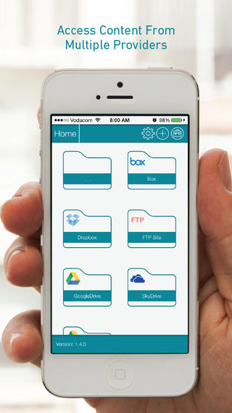  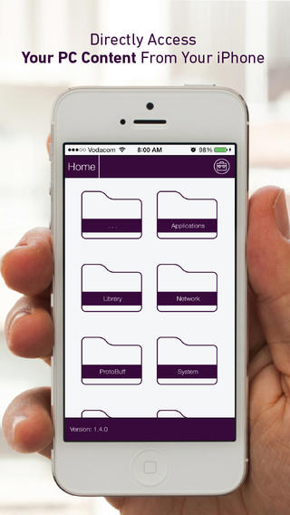

uniFile |  | - Gijima 6 months

Description
A multi platform app that allows users to connect to a range of different storage providers for documents and media. Storage providers include: Dropbox, Google Drive, Box, FTP, SFTP, Windows Share, Sharepoint, Secured Enterprise services and more

Key Responsibilities
- Responsible for architecting, designing, building and deploying the app to the Google Play Store.
- Created the web service layer that abstracts different data sources into a ‘Managed Provider’, allowing encryption, data hashing, auditing and more
- Developed the various providers like FTP, SFTP, Sharepoint, WebDAV etc for the Android app
- Design uniFile service to be a multi tenant cloud hosted as well as an on prim deployment

Technologies used
- Java, Android, .Net, C#
- SQL Server 2008

BoardView Professional |  | - Gijima 8 months
Description  A multi platform (tablets only) app for Meeting Group Management. BoardView is an enterprise solution to allow boards and meeting groups to go paperless. It is an on prim as well as a cloud hosted solution.  Key Responsibilities  - Responsible for architecting, designing, building the web services to interact with the applications.  - Developed a multi-tenant and multi data source system. Currently can use any relational database and Sharepoint 2010 and Sharepoint 2013  - Develop the sharepoint solution as part of BoardView deployment.  - Develop the round robin signing process server side implementation  Technologies Used  - .Net, C#  - SQL Server 2008  - TFS  Rewards and Recognitions  - Finalist at MTN App of the Year Awards in Enterprise and Innovation categories |  | 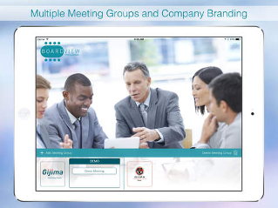  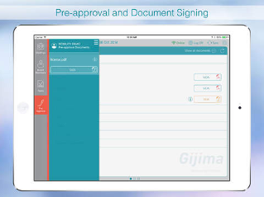

g-MO |  | - Gijima 6 months
Description  A cross platform hybrid app that allows Gijima’s clients to access the self help for users. The aim of gMO is to provide the ability for the end users to be able to check solutions for common problems before logging calls with help desk. It is an additional tool/service to regular help desk and is aimed at reducing the call volumen and improve on service quality and client satisfaction  Key Responsibilities  - Responsible for wrapping the app and deploying onto Google Play Store  - Created the web service layer that surfaces the relevant data for a user to the apps and the site  Technologies used  - Java, Android, .Net, C#  - SQL Server 2008 |  | 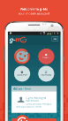  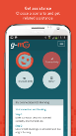

resolveIT |  | - Gijima 1 month
Description  An iPad application used by all Gijima Field Support Engineers for Incident Management(including: trip management, client signoff on device, full offline functionality and more)  Key Responsibilities  - Responsible for converting the official BMC Java api to a .Net dll to be used by the Windows Service  Technologies Used  - .Net, C#  - Mono ikvm |  | 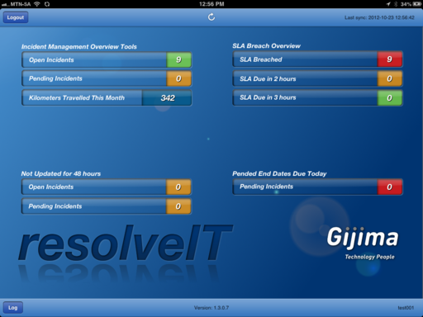  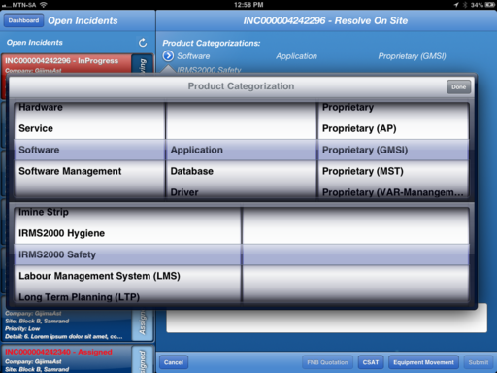

King IV IODSA |  | - Gijima 1 month
Description  iOS and Android application for the King IV Chapters  Key Responsibilities  - Responsible for building the Android app  Technologies Used  - Java  - Xml  - Android Studio |  | 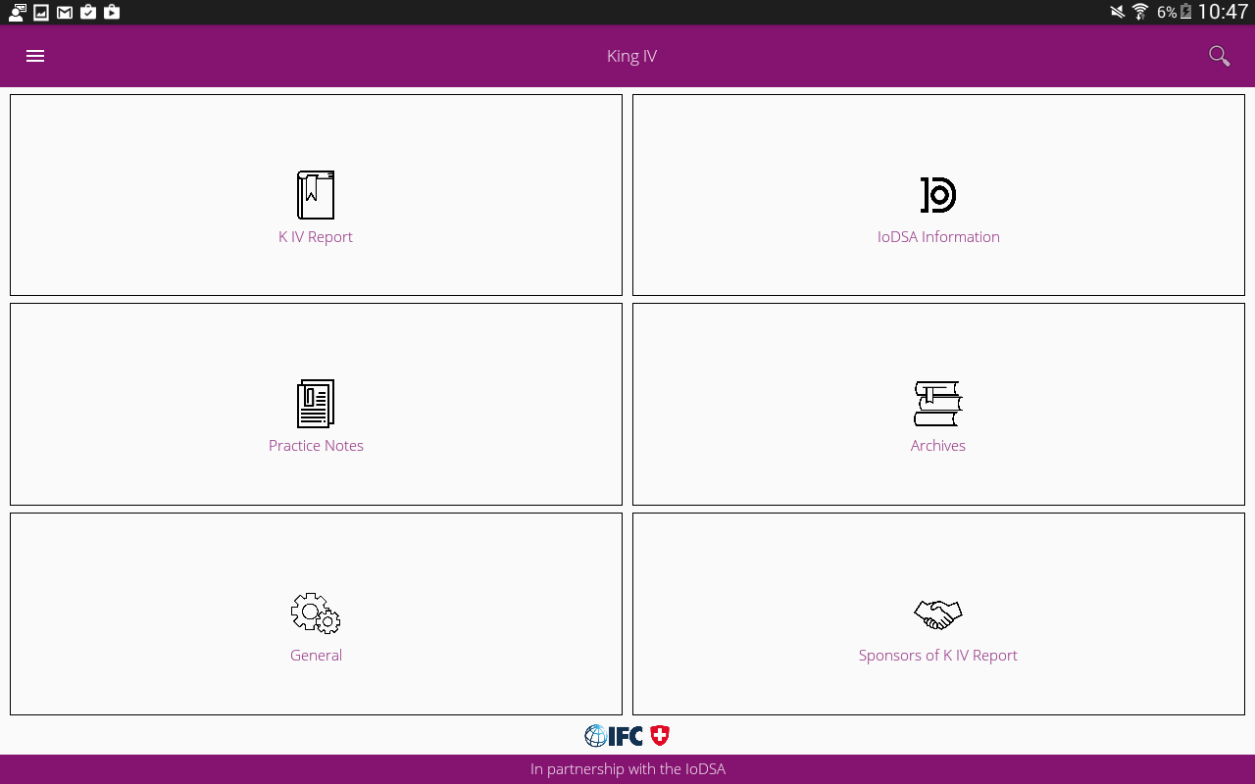  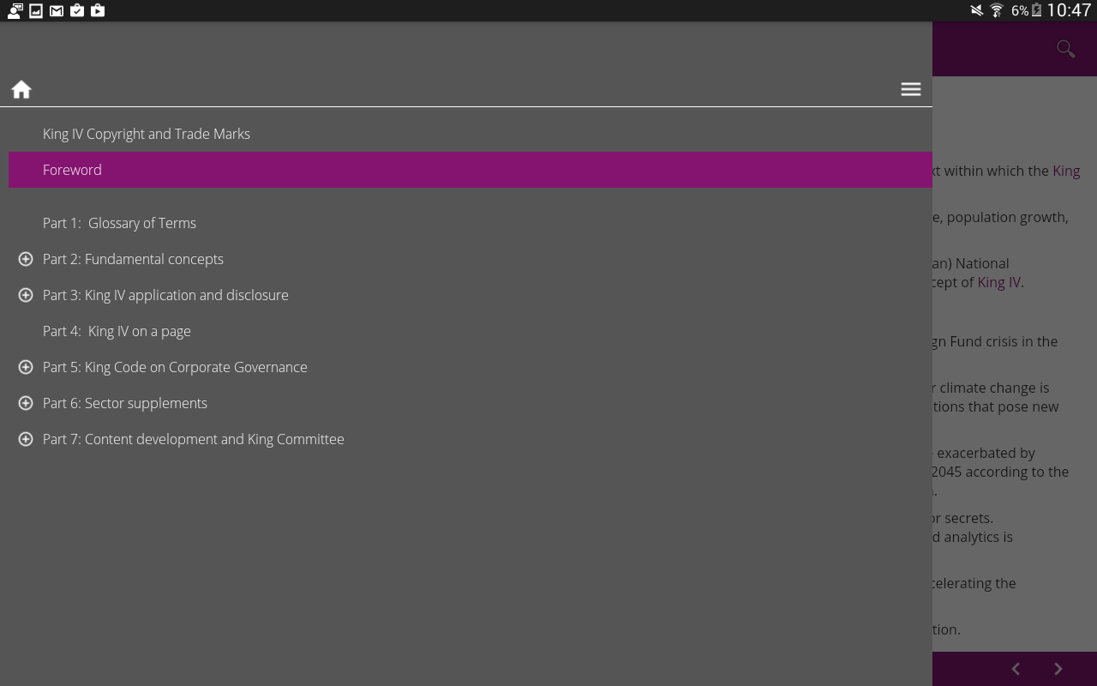

Licensing Service |  | - Gijima 8 months

Description
A multi tenant cloud hosted service which allows any Gijima’s Apps to verify the license key being used by the device user.

Key Responsibilities
- Responsible for architecting, designing, building the web services to interact with the applications and other application services.

Technologies Used
- .Net, C#
- SQL Server 2008
- TFS

MobileIT Platform |  | - Gijima 12 months

Description
A server and client side set of libraries to ease with development.

Key Responsibilities
- Responsible for architecting, designing, building the server side and client side libraries
- Libraries created for Server and Client Side Encryption/Decryption (Web Service, iOS, Android, Windows Universal)
- Push Notification from Server Side via Azure cloud to all platforms
- Audit and Service Logging for Server Side

Technologies Used
- .Net, C#, Objective C, Java
- SQL Server 2008
- TFS

Race Centre Tour De France |  | - Britehouse 5 months
Description  A website for tracking of the riders racing in the different cycling races organized by ASO. Primarily the Tour De France.  Key Responsibilities  - Responsible for maintaining and building the API code.  - Responsible for maintaining and building the front end code.  - Responsible for stored procedures optimization and build new stored procedures.  - Responsible for building new end points interfacing with the mongo db to do live tracking of the individual riders.  Technologies Used  - .Net, C#, Javascript, AngularJS 1.6  - Sitecore  - Akamai  - SQL Server 2012  - Github |  | 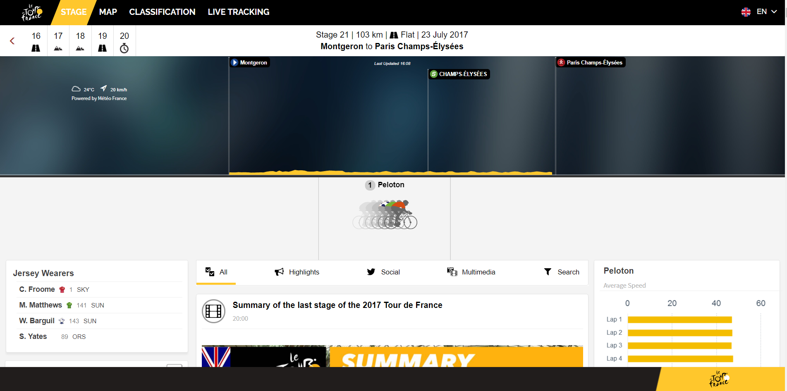  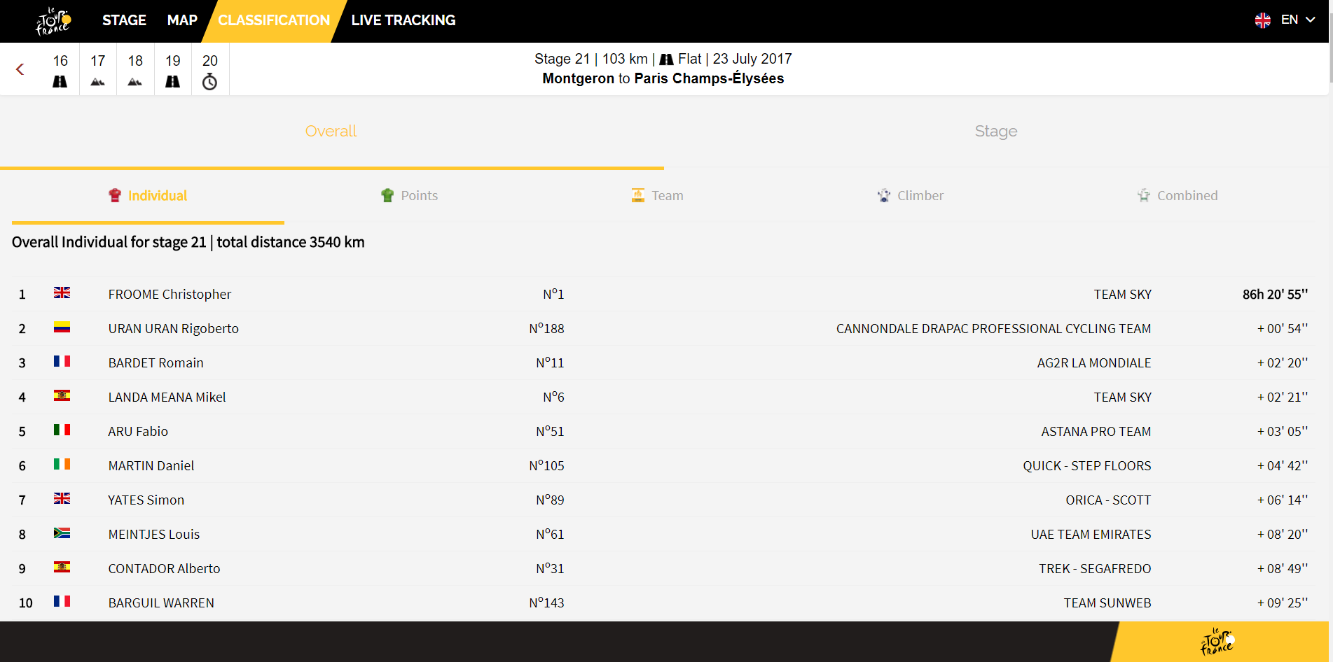

Makro mCard App |  | - Britehouse 2 months
Description  Britehouse was tasked with building the Makro mCard app for consumers.  Key Responsibilities  - Responsible for maintaining and building the API code.  - Responsible for integrating other Makro systems get the data for the app.  Technologies Used  - .Net, C#, Javascript, AngularJS 1.6  - SQL Server 2012  - Github |  | 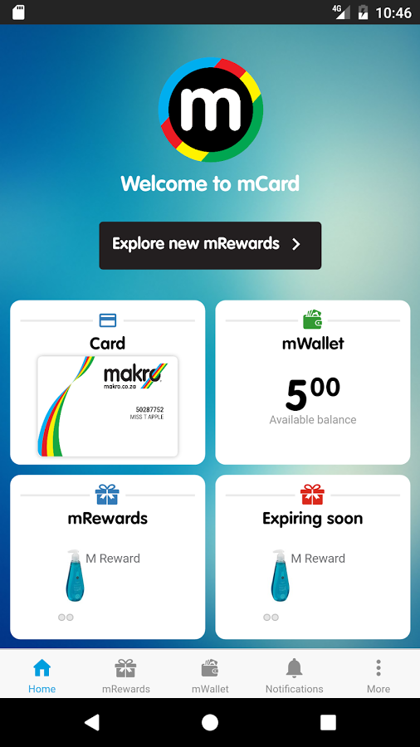

BMW SA |  | - Britehouse 2 months
Description  BMW needed an application for KPI reporting for their Nordics region as a pilot. The current KPI’s are calculated using Excel.  Key Responsibilities  - Responsible for maintaining and building the API code.  - Responsible for maintaining and building the system architecture.  - Responsible for guiding and consulting on the API infrastrcure. We used Azure App Service with Azure hosted Postgres and Azure Blob Storage  Technologies Used  - Java, Springboot,  - Azure App Services  - Azure Hosted Postgres  - Azure Blob Storage  - Angular 4  - Github |  | 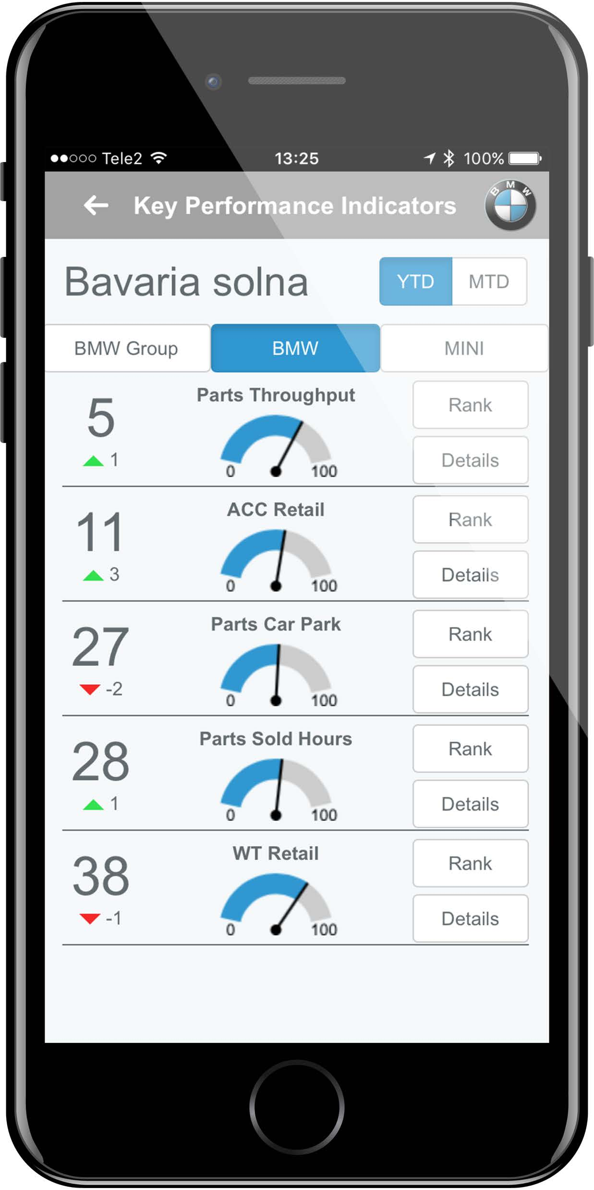

ImageViewer |  | - Britehouse 1 months
Description  One of Britehouse internal products has an image viewer component which is extremely slow. The goal was to build a micro service hosted in the cloud which would do the image handling.  Key Responsibilities  - Responsible for maintaining and building the API code. Done as Azure Function App  - Responsible for designing the database.  - Responsible for building the Azure Blob Storage Connector save and fetch images.  - Responsible for building exported functionality to save image data in an excel sheet with the sheet having link to images packages as a zip, shared as a downloadable link.  Technologies Used  - .Net, C#, Azure Function App  - SQL Server 2012  - Github |  | 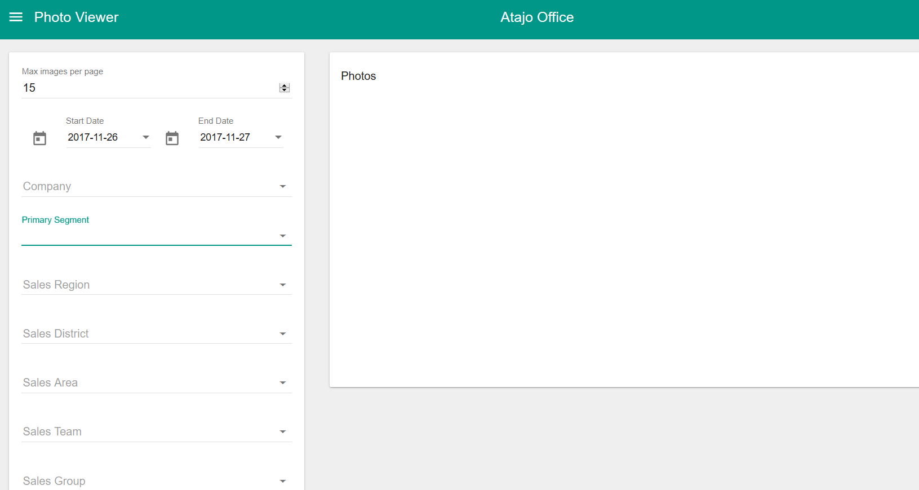

MADAPI BOOTSTRAP |  | - iOCO Current
Description  MADAPI is an API platform being built at MTN. The platform is an enabler for dev’s to connect to various systems across the MTN group through a REST services based platform.  Key Responsibilities  - Enhance and maintain the platform side of MADAPI  - Responsible for analysis and implementation of new technology to be used in MADAPI.  - Responsible for building the CI/CD services to enable API development and deployment across various OPCOS in MTN Group.  - Responsible for building the bootstrap system for MADAPI platform. The bootstrap system allows to create a new API for developers. The system creates new repositories, Kubernetes deployment files, azure pipeline for the new API. It also allows to generate model objects from the swagger spec.  Technologies Used  - Java, Springboot, Yaml  - Monogodb  - Github, Azure Pipelines, Openshift |  | 